**MAD Assignment Report**

Application Name: LifeNote

Team Member Name: Deon Chua, Clarence Chai, Pua Yu Xuan

Problem Statement:

Sometimes, people forget what they need to do in our busy world today. Thus, our application caters to people of all ages for them to remember what they set out to do by typing it into our application which will enable them to remember to do the tasks in an organized manner.

Description of App:

After downloading the application, the user will be able to create an account and sign in using their account by entering a username and password which will be stored using sharedpreferences. The password will have to contain at least one lowercase letter, uppercase letter, number and a special symbol.

**Main Login Page**

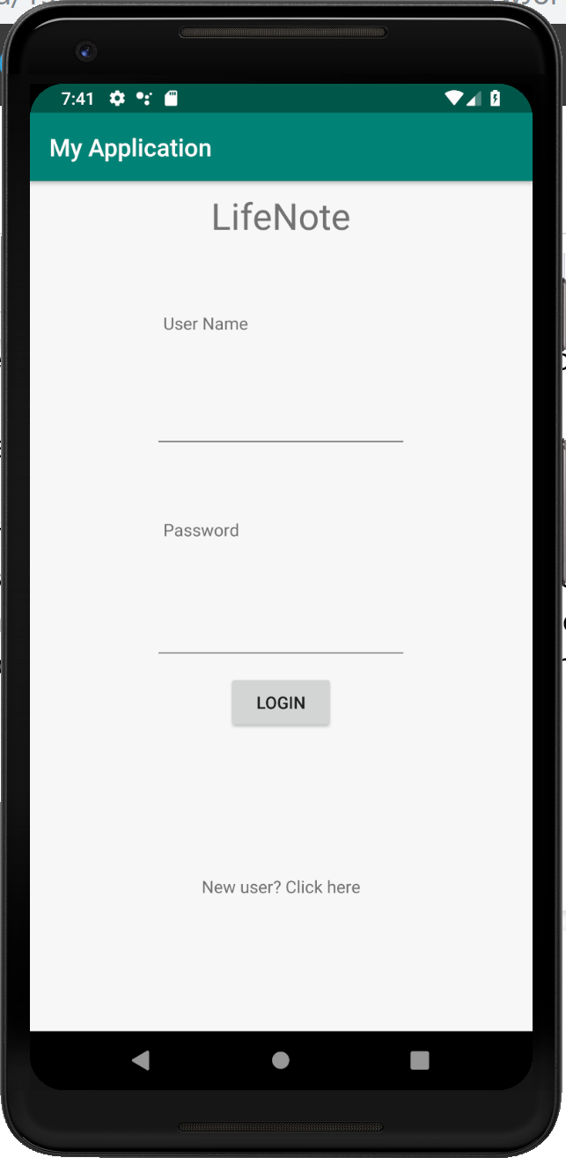

This screenshot shows how the login page is like and if the user does not have an account, he or she can create an account by clicking on the “New user? Click here” at the bottom of the page. The user can try to login and if the account is not created yet, a pop up will appear that says “Invalid Login” and if the account is correct, a pop up will appear saying “Successful Login” and the user will be redirected to the page where they will be able to use the application.

**Creating New User**

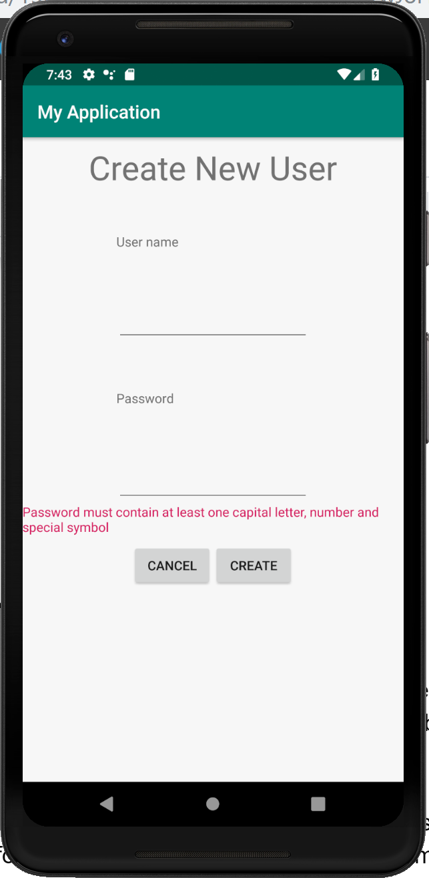

The user will then be redirected to this page if they click on “New user? Click here”. On this page, they can create an account by entering a username and password and then pressing the button “Create”. If the password does not meet the validation criteria, a pop up will be shown saying “Invalid User Creation, Please Try Again” and if the validation is met, an account will be successfully created with the message “New User Created Successfully” and the account will be created. The user will then be redirected to the login page where they can login. The user can also press the “Cancel” button on this page to be redirected back to the login page.

The application contains a to-do list that the users can use to store their information. Users are able to key in information by adding a to do list item into the application and the user will also be able to edit the title of the item. In the item, the user will be able to add more information on what or how you are going to complete the task and edit or delete the information.

**Main Page For ToDoList**

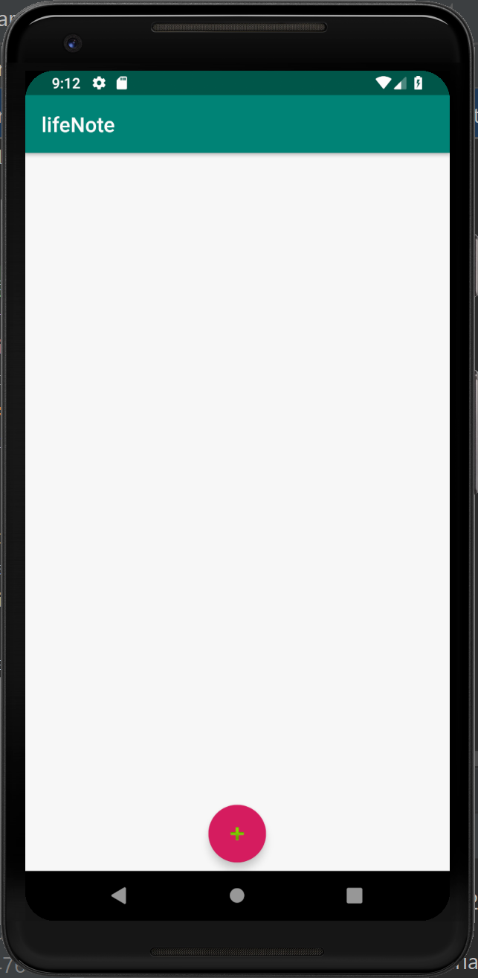

This is the page that the user will be redirected to after they successfully login. The plus logo at the bottom of the page can be clicked to add a to do list item. The page consists of a recycler view where it will display the list of notes that has been created when the floating action button has been clicked. An edit text will appear when the plus button is clicked. This edit text will allow the user to type in the title of the ToDoList that they wish to type in. This will be updated in the SQLLite database.

**Sub-Page for ToDoList**

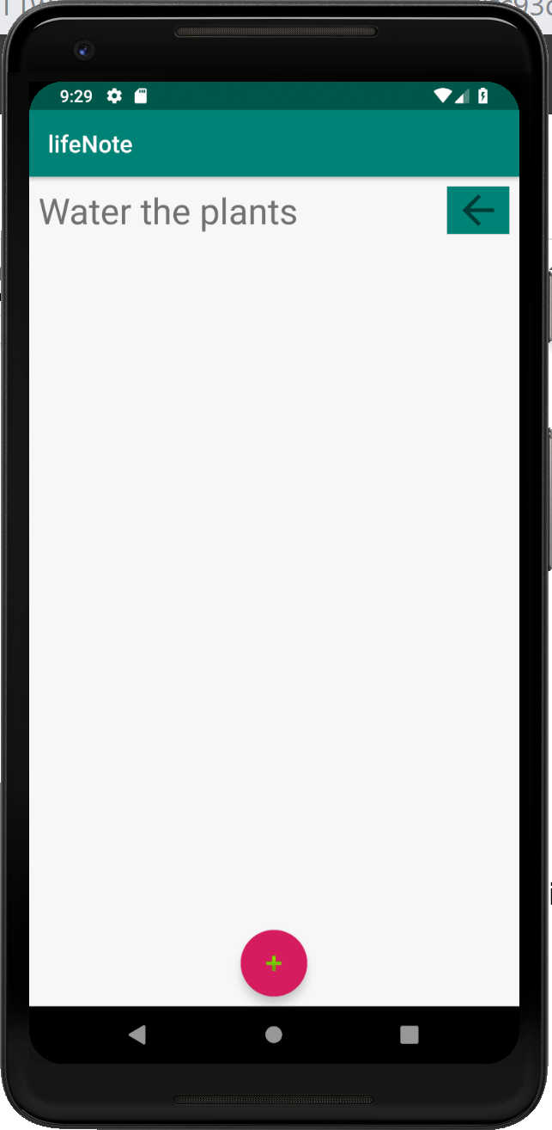

This is what the page will look like after adding an activity called “Water the plants”. Users can choose to edit or delete the ToDoList if they choose to do so. If the user clicks on the TextView they will be redirected to another recycler view where they can choose to add more sub lists to the ToDoList.

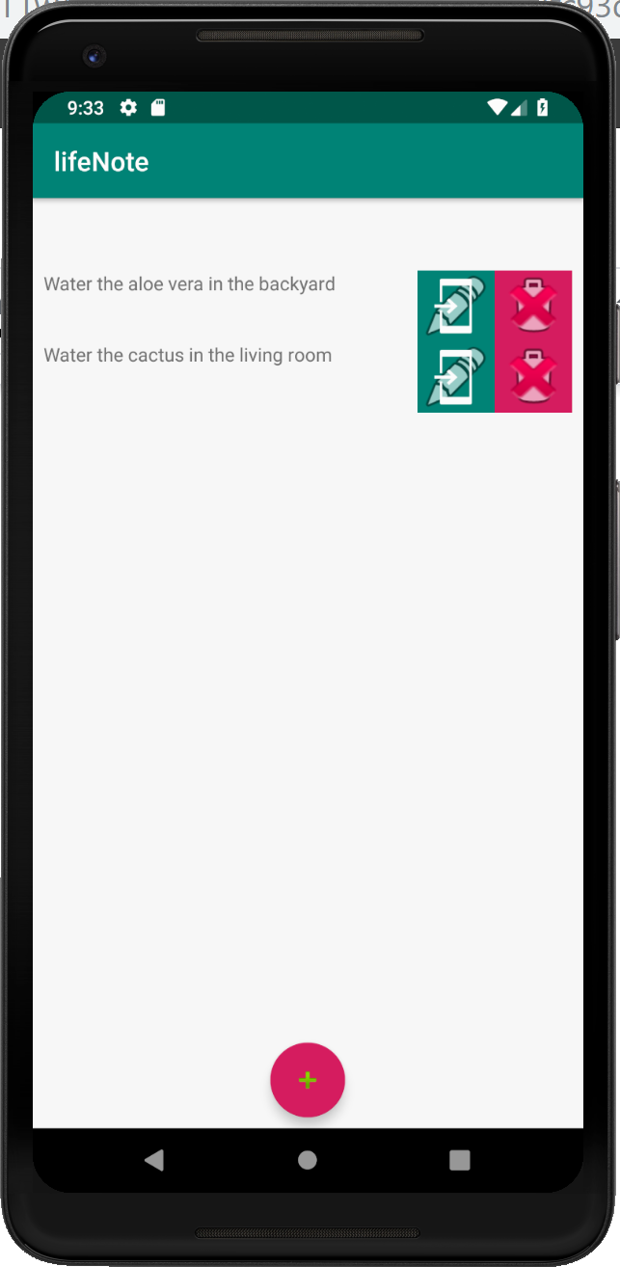

Under each main event, there are activities inside for the user to do which can be edited and deleted. This can allow users to change the text that they had inputted in earlier into something else, as well as allowing them to delete the notes if they choose to do so. In this page, there are two image views which can be clicked upon by the user. One will allow the user to edit the text that has already been inputted there, while the other will allow the user to delete the notes. When the green edit image view is clicked, an edit text will pop up which will allow the user to change the original text. This is through the edit setOnClickListener where it will update the items in the list in SQLLite database.

**Deleting Function**

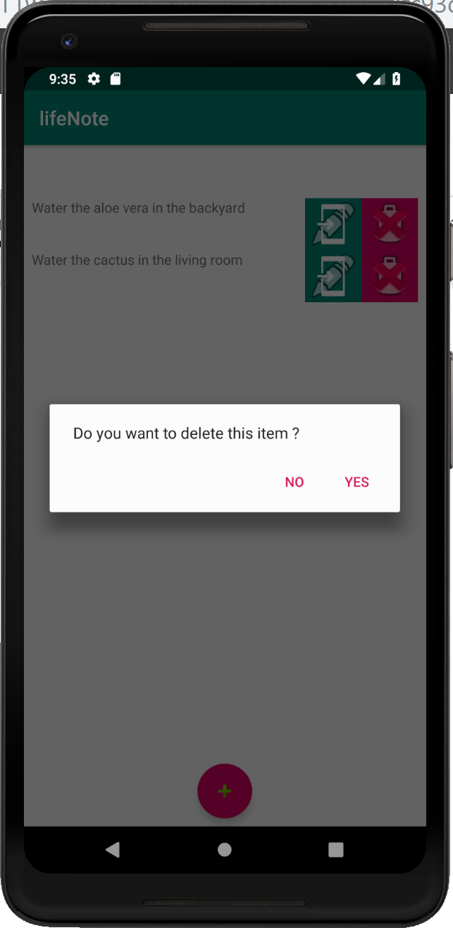

Once the activity has been completed, the user can delete the activity by pressing the delete button and pressing yes to confirm that they want to delete the item. This is through a dialog box will appear which allows the user whether they want to delete the note or not. This will trigger the delete setOnClickListener which will cause it to delete the items from the list in the SQLLite database.

Role and Contribution of each member:

Login/Registration: Deon

Adding/Deleting/Editing ToDoList: Clarence

SQLLite Database: Yu Xuan